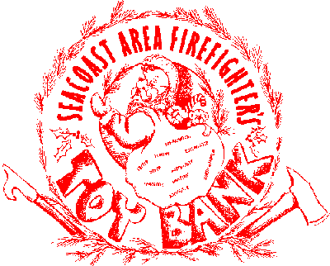
Reference #_2020-_____________

North Hampton Professional Firefighter’s Toy Bank
IAFF Local 3211

Mother’s/Father’s Name _________________________________________________

Home Street Address ________________________________________ Apt#______

City ___________________________________ State _________ Zip ____________

Phone ________________________ Email ________________________________
(we must have a phone number)

Other info. or special needs _____________________________________________

____________________________________________________________________

Are you a Veteran Yes___ No___ If Yes, what branch ______________________
Would you like wrapping paper included with the gifts? Yes___ No ___

This program is for children 14 and younger

Parents please fill out Front and Back Completely. If you have requests please be specific when filling out the toy requests. We will make every effort to fill your requests. Our toys are all donated so we make no guarantees. We do not fill music/toy requests with Parental Warnings.

Be specific!
Very helpful Not so helpful
Baseball mitt Sport stuff
Shrek 3 DVD Kids movies
Monopoly board game Board games
Play Dough Fun factory Kids toys
Drawing chalk & oil paint Art stuff
Any application that is not filled out correctly and/or has misinformation on it may not be honored. Please have a working method of contacting you if you want your requests to be fulfilled. Be aware that the toy bank checks its list with other local agencies and if your child/ren are being taken care of by another agency, we reserve the right to remove your child/ren from our list.

PLEASE RETURN TO THE NORTH HAMPTRON FIRE DEPARTMENT
Application Deadline is November 30, 2020. Any applications submitted after deadline may not be able to be filled with specific requests.
Gifts MUST be picked up by December 24, or they will be put back into the toy bank.
For questions or info please email Angelo at: nhpff3211@yahoo.com

Childs Name________________________________________________ M F Age __________

Gift Wishes

1._________________________________________ 2._____________________________________________

3._________________________________________ 4._____________________________________________

________________________________________________________________________________________

Childs Name________________________________________________ M F Age __________

Gift Wishes

1._________________________________________ 2._____________________________________________

3._________________________________________ 4._____________________________________________

_________________________________________________________________________________________

Childs Name________________________________________________ M F Age __________

Gift Wishes

1._________________________________________ 2._____________________________________________

3._________________________________________ 4._____________________________________________

_________________________________________________________________________________________

Childs Name________________________________________________ M F Age __________

Gift Wishes

1._________________________________________ 2._____________________________________________

3._________________________________________ 4._____________________________________________

_________________________________________________________________________________________

Childs Name________________________________________________ M F Age __________

Gift Wishes

1._________________________________________ 2._____________________________________________

3._________________________________________ 4._____________________________________________
****Must have Phone Number on front sheet***

